Ulcerative proctitis & distal colitis: FAQs

What is proctitis?
Faeces travels through the colon (large intestine), ending up in the sigmoid (situated inside the left lower part of the abdomen) and then the back passage or rectum. Faeces then pass though the anus on its way out of the body.

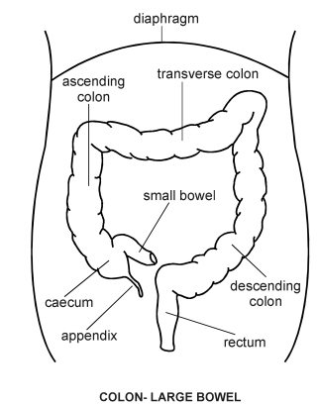
Descending colon
Sigmoid colon

If the rectum gets inflamed for whatever reason, this is called proctitis and if this extends further up inside to affect the sigmoid this is called proctosigmoiditis or distal colitis. Although proctitis can be caused by infections, including sexually transmitted diseases, most usually this is a limited form of inflammatory bowel disease (IBD) or colitis confined to a few centimetres affecting the lining of the rectum and just further upstream in the sigmoid colon.
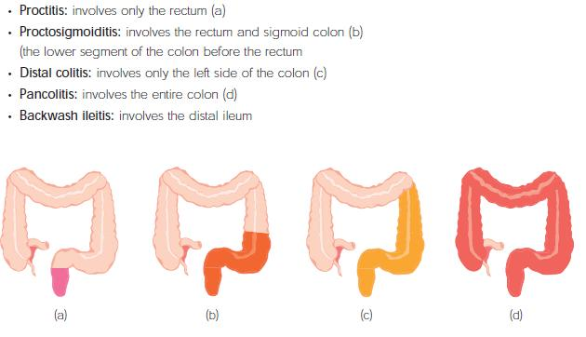
The inflammation causes the lining to become ulcerated and these raw areas bleed easily so that both blood and sticky mucus with pus can be seen passing with the faeces. Although only a short segment of the rectum is affected, undiagnosed patients often become very miserable and worried about severe and unpleasant symptoms.
What are the symptoms of proctitis?
Typical symptoms of ulcerative proctitis were once eloquently summed up by one of my patients using the initials “BMW”:
- Blood
- Mucus
- Wind
Other symptoms include:
- Frequent or continuous sensation that you need to have a bowel movement
- A feeling of fullness and incomplete emptying in your rectum
- Frequency and urgency to visit the toilet 10 or more times a day, only to have a “false alarm”, pass BMW or unsatisfactory small pieces of stool. This is quite different to the bloody liquid diarrhoea suffered by patients with more widespread colitis involving the colon.
- There may also be symptoms quite similar to those of irritable bowel syndrome (IBS):
- Pain with bowel movements
- Rectal pain
- Pain on the left side of abdomen
- Bloating and rumbling
- A feeling of constipation

Important factors to note are:
- The symptoms do not usually cause disturbance during the night
- The patient’s general health remains good, with no weight loss (unlike widespread ulcerative colitis)
- Blood tests are usually normal
- The presence of blood does not mean that you have bowel cancer, but if you have not been diagnosed with proctitis, colitis or Crohn’s disease before it is most important to consult your doctor to get an accurate diagnosis without delay.
Why have I developed proctitis?
Like ulcerative colitis and Crohn’s disease, proctitis is associated with a complex array of faulty genes which causes the immune system inside the lining of the rectum to become very sensitive to the bugs in the faeces, leading to inflammation. There may be somebody else in the family with either of these inflammatory bowel diseases. Environmental triggers such as some elusive change in the diet or smoking habit may also contribute. Proctitis can affect the young or old, men or women, rich or poor – it does not discriminate.
Why does proctitis seem to come and go?
Proctitis is a relapsing and remitting disease. In many people it gets better for a while and then flares up again. The reasons for this are unknown but stress seems to make some symptoms worse. Mesalazine medicines such as Pentasa, Asacol or Mezavant, to name but a few, can reduce the frequency of these flare-ups but cannot prevent them completely.
Can my proctitis turn into ulcerative colitis?
There is no way of telling. In most people, proctitis never spreads from the rectum. In up to 30% of sufferers, it can spread backwards up the colon and become distal colitis or total colitis. Patients can become unwell in this situation with weight loss, tiredness, anaemia and weight loss and will normally need re-evaluation by their Gastroenterologist.
What tests will I need?
Often, a short telescope examination (rigid sigmoidoscopy) can diagnose proctitis at the initial consultation with a Gastroenterologist. Sometimes the patient can be reassured that piles (haemorrhoids) are the cause of the bleeding and that there is no evidence of proctitis at all. If the inflammation of the lining continues above and out of range of the sigmoidoscope, a deeper examination using a flexible sigmoidoscope or colonoscope may be required later to determine the extent of the colon affected by the inflammation. Samples of the lining (biopsies) should always be taken to confirm the diagnosis by inspection under the microscope and for full documentation. Some patients have constipated stools loading higher up inside the bowel and an xray of the abdomen can be helpful to confirm this.
Can proctitis be treated?
Yes. Treatment with mesalazine suppositories slipped easily into the back passage is highly effective to soothe the inflammation by direct contact with the raw lining. Pentasa 1g at bedtime is the most effective treatment to settle a flare-up, usually for 4 weeks or at least 2 weeks after the bleeding has stopped. Mesalazine enemas, such as Asacol foam 1g, can disperse further up the colon to reach the sigmoid and descending colon and so are the more usual treatment for distal colitis. See my patient information leaflet entitled “suppositories and enemas” in the Medicines for the Gut section for further tips on using suppositories and enemas.
Do I have to use suppositories or enemas?
No. Mesalazine can be taken in tablet form by mouth, such as Pentasa or Asacol, but has to travel though the body inside the small intestine to reach the colon and eventually the sigmoid and rectum before becoming effective. Occasionally, steroid tablets can be effective. Some patients can become very constipated higher up the colon where the lining is not inflamed and this can easily be settled by taking a bulk laxative such as Fybogel or Celevac (methylcellulose). Patients are often surprised about this, especially if they are already troubled with frequency of going to the toilet to pass faeces over 10 times a day. An xray of the abdomen can be helpful to confirm this.
Can I prevent further attacks?
Some people only have one attack of proctitis, but this is unusual. Most people with proctitis have further attacks over the years. Mesalazine tablets are used to reduce the chances of a relapse in people whose symptoms flare up very often. These tablets may then need to be taken regularly and usually for life.
Will changing my diet help?
There is no good evidence that changes in your diet will help in proctitis, but avoiding constipation by taking plenty of fibre and roughage can be very helpful.
Could surgery help?
No. It would be most unusal for a patient to need to have the colon removed for proctitis or distal colitis. Proctitis is best treated with medicines. For particularly stubborn proctitis, not responding to oral and rectal mesalazine, addition of a steroid or immunosuppressant such as azathioprine (Imuran) may be very helpful.
Does proctitis lead to cancer?
No. In widespread ulcerative colitis there is a small increased risk of colon cancer, but there is no evidence that this is true in proctitis or proctosigmoiditis – the risk is no greater than in the general population. For this reason, regular checks with colonoscopy that patient with wisdespreas ulcerative colitis undergo is unnecessary. Patients should be encouraged to seek specialist medical advice from their Gastroenterologist if their symptoms change.
Where can I find out more about proctitis and distal colitis?
Further helpful information is available from Crohn’s and Colitis UK www.nacc.org.uk
Dr Max Pitcher, August 2010

